**UID LAB EXPERIMENT 8**

**Create storyboards to represent the user flow for a mobile app (e.g., food delivery app) using Balsamiq.**

**SANJAY KISHAN D**

**230701287**

**1. Introduction**

This document provides accurate screen designs based on the four new images provided, correcting previous inconsistencies. The flow covers: account creation → restaurant selection → payment → order tracking.

**2. Corrected Screen Documentation**

**Screen 1: Account Creation**

Purpose: User registration

Components:

"FOODIE" logo (header)

Prompt: "DONT HAVE AN ACCOUNT? CREATE ONE"

Design Notes:

* Minimalist design with single call-to-action
* Missing input fields suggest this is a secondary screen

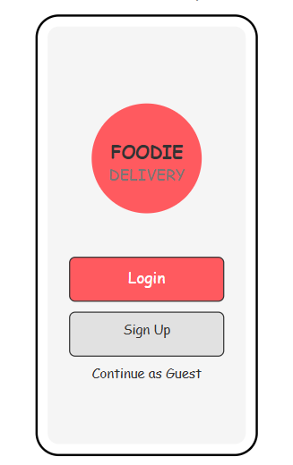

**Screen 2: Restaurant Selection**

Purpose: Browse dining options

Components:

* Header: "FOODIE" + search bar
* Featured venue: "HOTEL DELMA"
* Categories:
* "PIZZA"
* "PASTA"
* "BURGER"
* "BRIYANI"
* Design Notes:
* Search placeholder appears localized/informal
* Category names show creative spelling variations

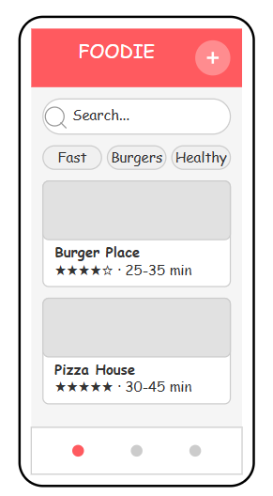

**Screen 3: Cart**

Purpose: enable user to collective add items to buy it. And also ensure they can able to review their items once again.

Components:

* Header: "CART"
* Featured venue: Display total cost
* Categories:

1. Price allocation based on food items and extra toppings.
2. Displays the tax allocation for the respective and delivery charges based on distance from restaurant to place of delivery

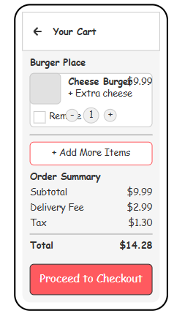

Screen 3: Payment

* Purpose: Secure transaction
* Components:
* Header: "PAYMENT"
* Fields:
* "PHONE NUMBER" (pre-filled: 9876543210)
* "CARD NO." (masked: 1234 8907 8555 ****)

Options:

"ONLINE PAYMENTS"

* "GPAY OR PAYTM"

Action: "PAY" button

Design Notes:

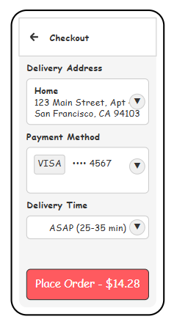

* Shows real masked card number format

Specific payment app references

Screen 4: Order Tracking

Purpose: Delivery status

Components:

Header: "FOODIE"

Status: "ORDER ARRIVING IN 10 MIN"

Details:

* "ITEM DETAILS"
* "DELIVERY PARTNER DETAILS"

Action: "CANCEL ORDER" button

Design Notes:

* Clean status notification
* Two-tier detail structure

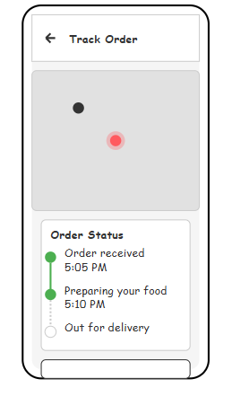

3. User Flow Correction

1. Account Creation → 2. Restaurant Selection → 3. Payment → 4. Order Tracking

4.Balsamiq Implementation Guide

1. Text Components:

* Used exact text from images

2. Search Bar:

* Added magnifying glass icon + placeholder text

3. Payment Card:

* Used "****" masking for card numbers

4. Status Screen:

* Added countdown timer visual near "10 MIN" text